- Physical Network Topology

Q.1 Open Cisco Packet Tracer and create a new project file named 'HomeWiFiNetwork.pkt' with three PCs and one wireless router connected appropriately?

Answer
- Creating the Packet Tracer Network
I created a new network in Cisco Packet Tracer and saved the project as:
- HomeWiFiNetwork.pkt
The network contains:
- 1 × 819HGW Wireless Router
- 1 × Cisco 2960 Switch
- 3 × PCs
The wireless router is connected to the switch, and all three PCs are connected to the switch using Ethernet cables.
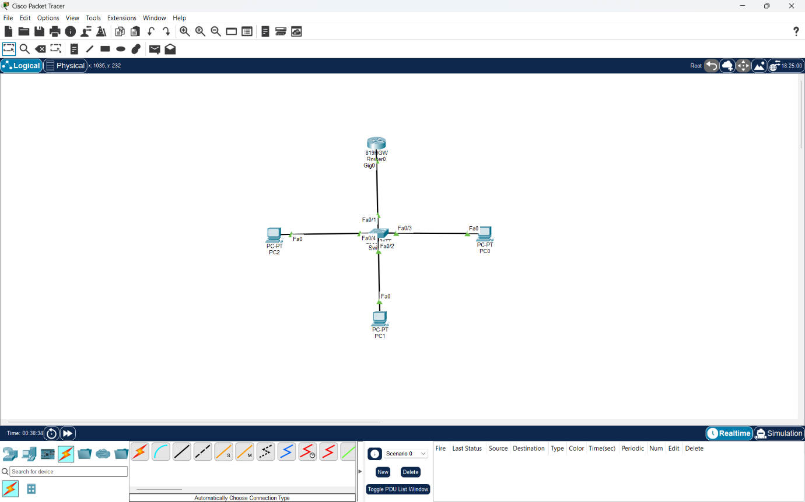
- Result:
The home network topology was created successfully with three PCs connected to the wireless router through the switch.

Q.2 Assign static IP addresses to each PC in your Packet Tracer network so they are on the same subnet (e.g., 192.168.10.x), and configure the default gateway to the router's IP?

Answer

- Assigning Static IP Addresses
I assigned static IPv4 addresses to all three PCs in the 192.168.10.0/24 network.

Device | IP Address | Subnet Mask | Default Gateway
- Router | 192.168.10.1 | 255.255.255.0 | -
- PC0 | 192.168.10.10 | 255.255.255.0 | 192.168.10.1
- PC1 | 192.168.10.20 | 255.255.255.0 | 192.168.10.1
- PC2 | 192.168.10.30 | 255.255.255.0 | 192.168.10.1

All PCs are on the same subnet and use the router's IP address 192.168.10.1 as their default gateway.

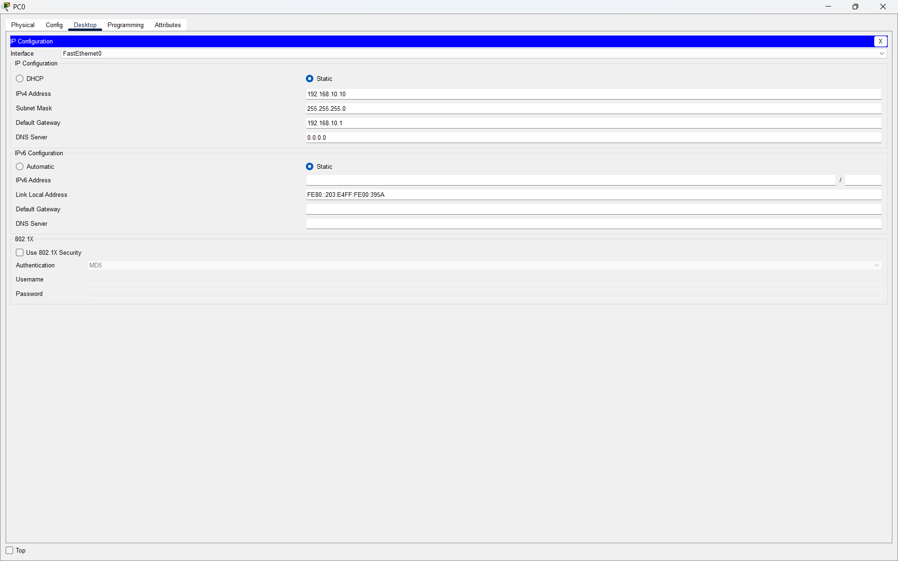

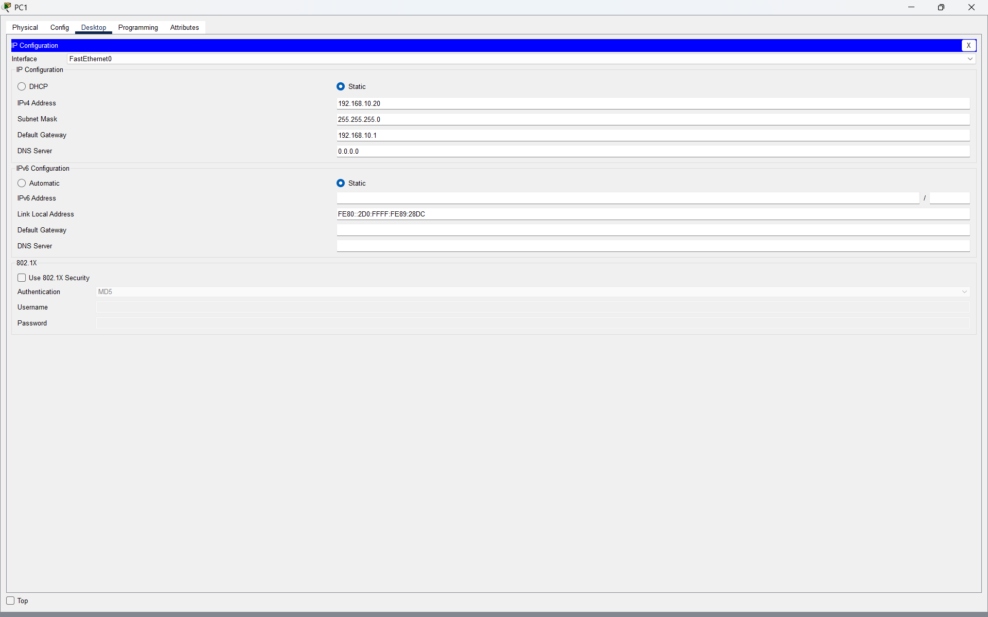

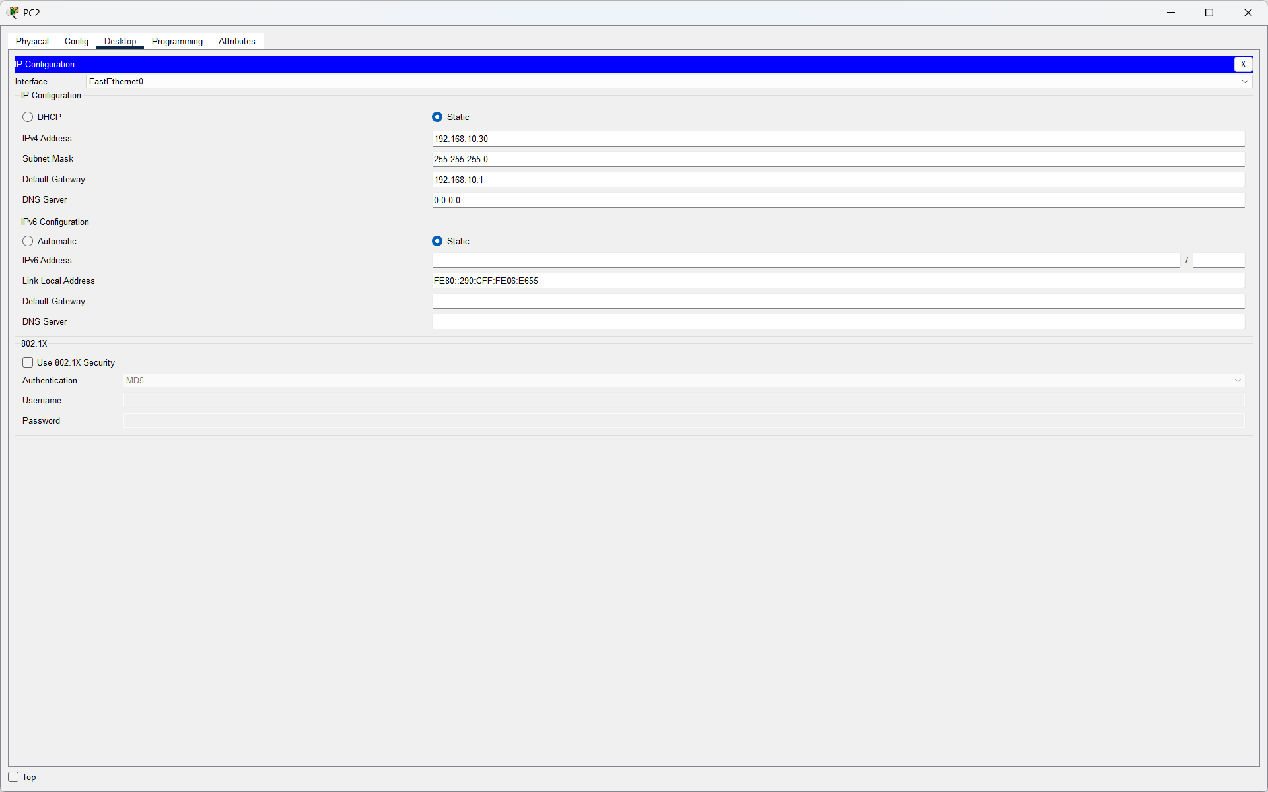

- Result:
Static IP addresses were successfully assigned to all three PCs.

Q.3 Test connectivity by using the Packet Tracer 'ping' tool to verify that all PCs can communicate with each other and the router.<br><br><em><strong>Hint:</strong> Use the Command Prompt tool on each PC and type 'ping [other PC’s IP]'.</em>?

Answer

- Connectivity Test
I tested connectivity from PC0 to the other devices using the ping command.
Ping to PC1: ping 192.168.10.30
Ping to PC2: ping 192.168.10.10
Ping to Router: ping 192.168.10.1

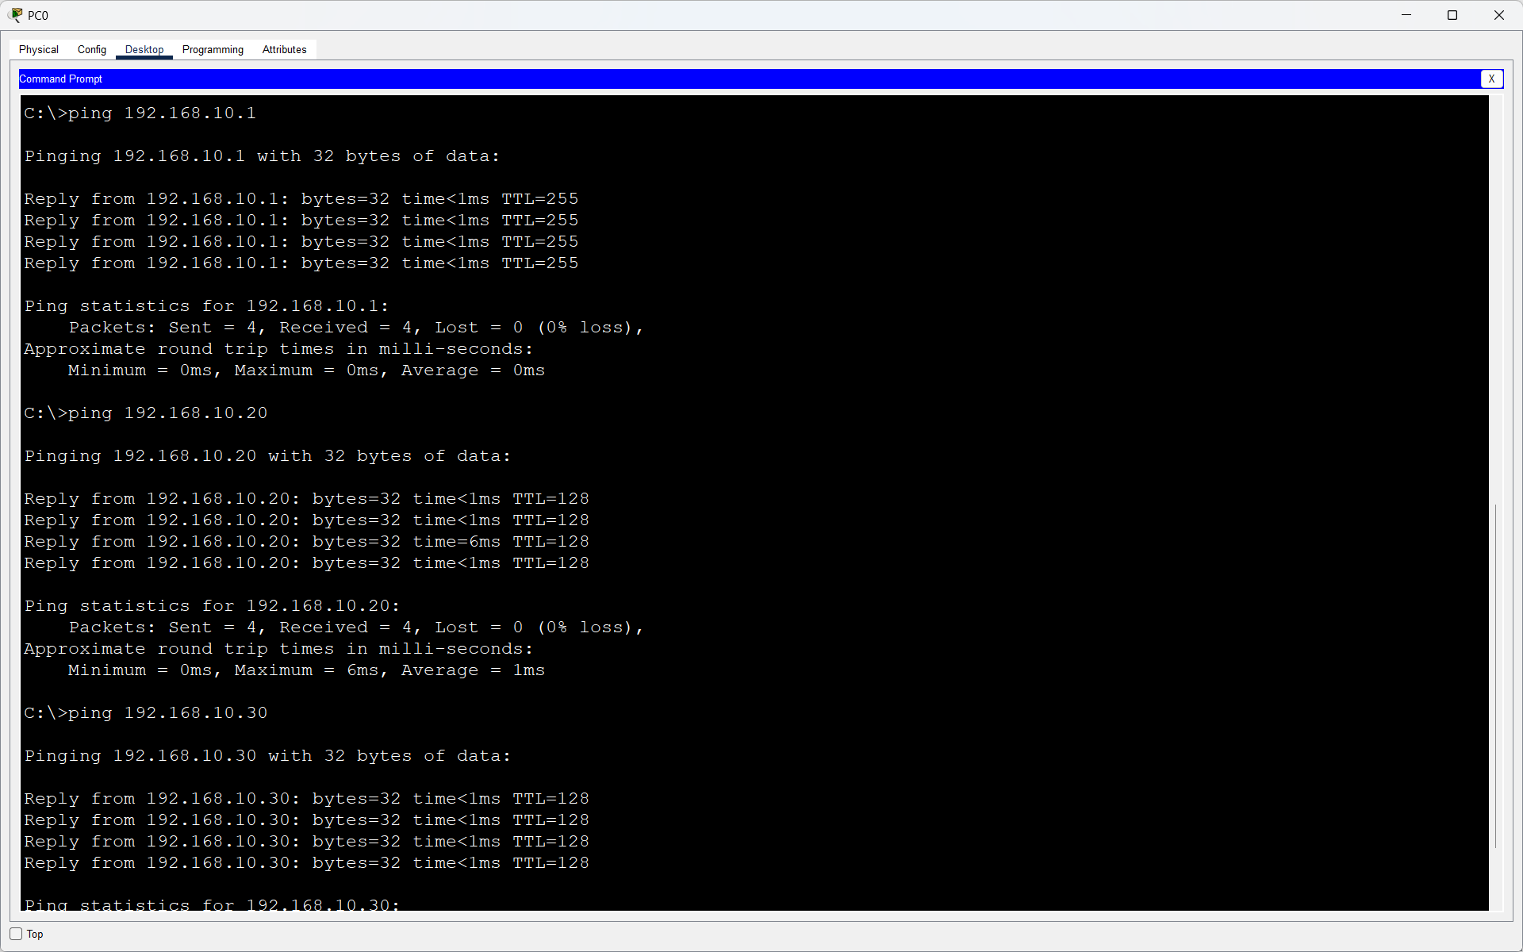

- Result:
All ping tests were successful with 0% packet loss. This confirmed that all PCs and the router were connected correctly and could communicate on the same network.

Q.4 Document each step you took to build and configure your Packet Tracer network, including screenshots of your topology and the IP configuration windows for each PC, in a Word or PDF file?

Answer

- Documentation of Packet Tracer Network Setup
I created and configured a small home network in Cisco Packet Tracer.
- Step 1: Create the Network Topology
I added the following devices:
- 1 × 819HGW Wireless Router
- 1 × Cisco 2960 Switch
- 3 × PCs
The router was connected to the switch, and all three PCs were connected to the switch using Ethernet cables.
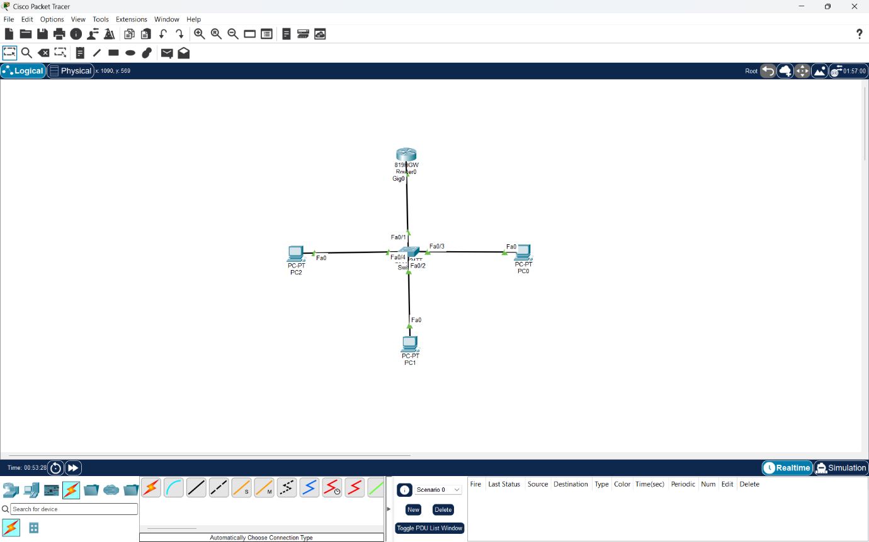
- Step 2: Configure the Router
I configured the router with:
Router IP Address: 192.168.10.1
Subnet Mask: 255.255.255.0
- Step 3: Assign Static IP Addresses to the PCs
Device | IP Address | Subnet mask | Default Gateway
- PC0 | 192.168.10.10 | 255.255.255.0 | 192.168.10.1
- PC1 | 192.168.10.20 | 255.255.255.0 | 192.168.10.1
- PC2 | 192.168.10.30 | 255.255.255.0 | 192.168.10.1

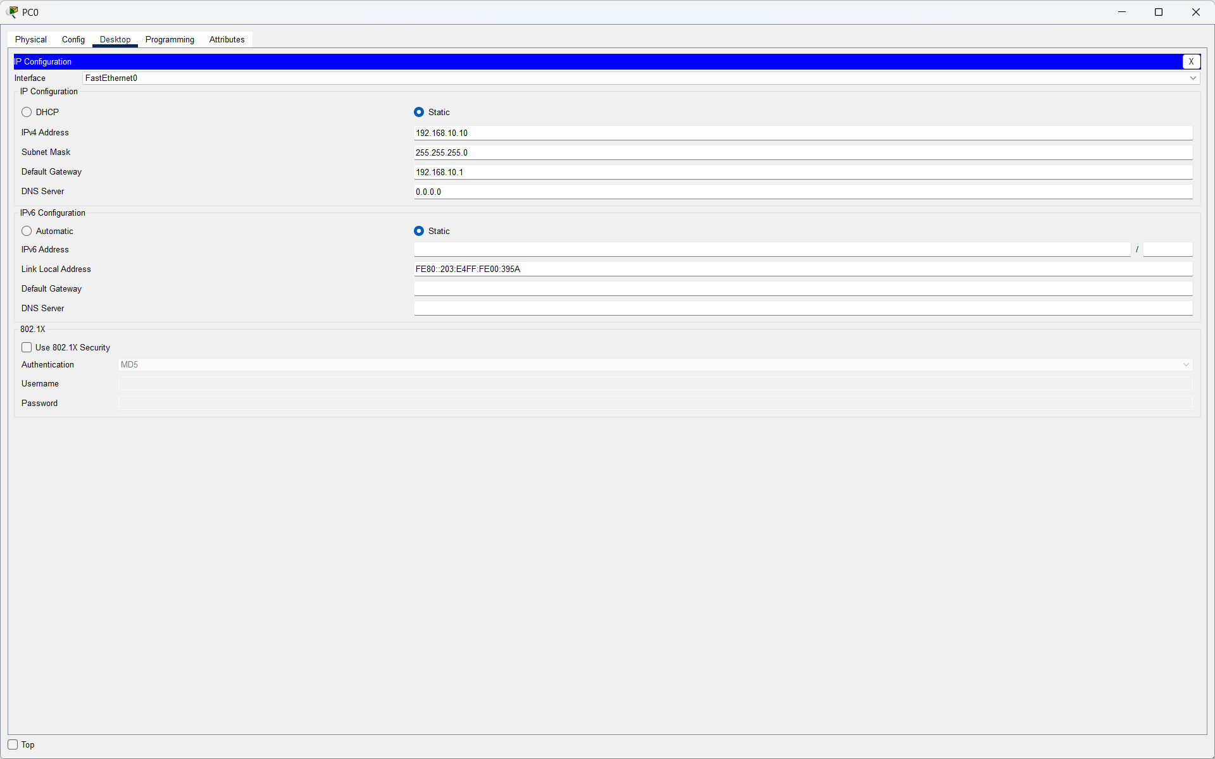

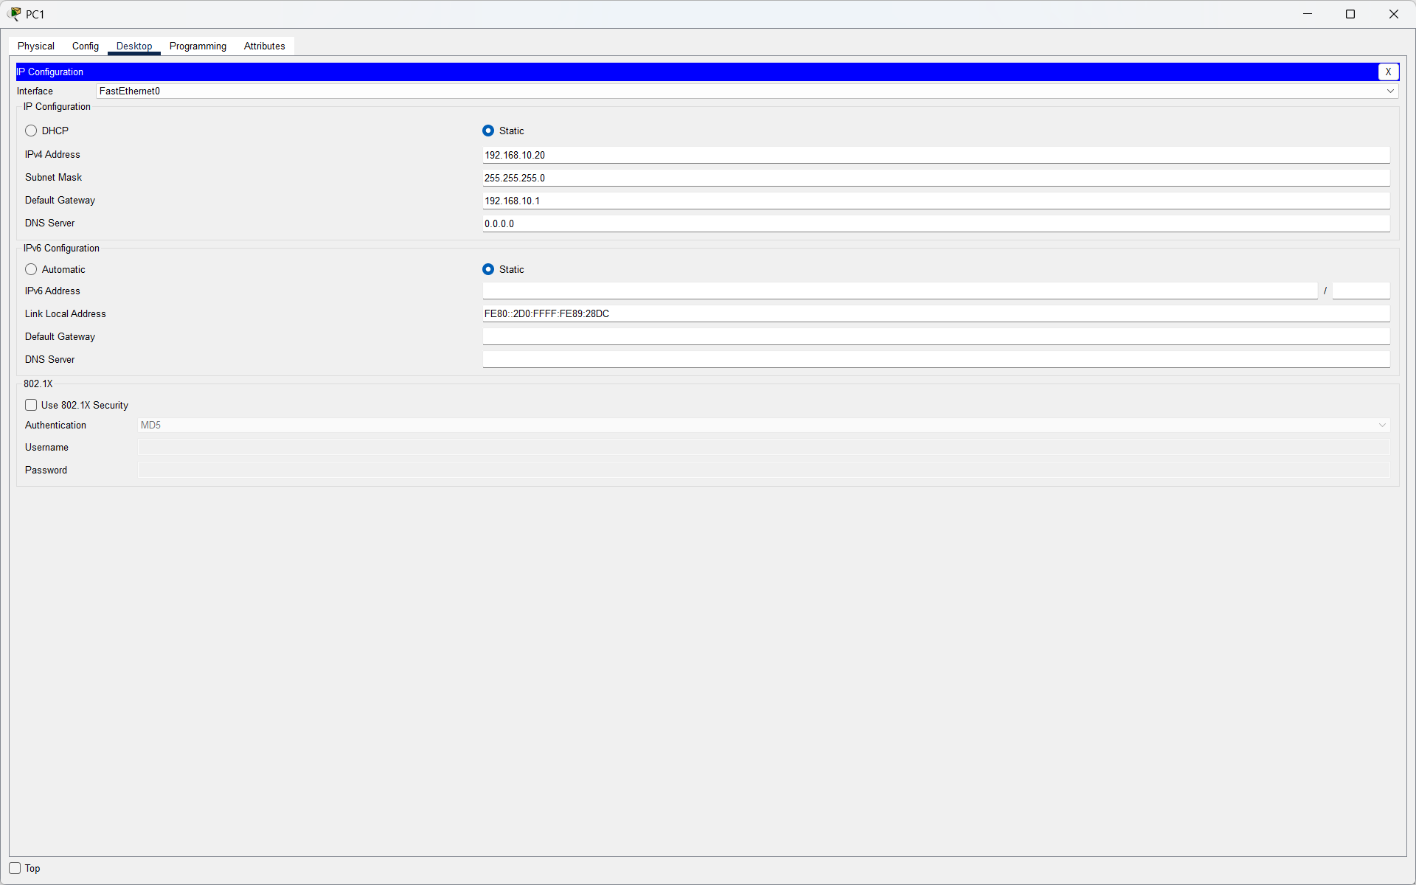


- Step 4: Test Connectivity
I used the Command Prompt on PC0 to test connectivity with the other PCs and the router.
ping 192.168.10.20
ping 192.168.10.30
ping 192.168.10.1

- Result

All ping tests were successful with 0% packet loss. This confirmed that all three PCs were correctly configured on the same subnet and could communicate with each other and the router.
Finally, I saved the Packet Tracer project as:
HomeWiFiNetwork.pkt

